1. Introduction to Recurrent Neural Networks (RNN)
A Recurrent Neural Network (RNN) is a type of neural network designed to process sequential data. Unlike traditional neural networks, RNNs remember previous inputs using a hidden state.
Typical data where RNNs are useful:
- Text (sentences, paragraphs)
- Time series data (stock prices, weather)
- Speech signals
- Video sequences
Example tasks:
- Language translation
- Sentiment analysis
- Speech recognition
- Time-series prediction
These models became popular in NLP research led by organizations such as Google Brain and OpenAI, although newer architectures like Transformer (deep learning architecture) are now widely used.

2. Why RNNs Were Introduced
Traditional feedforward neural networks assume:
- Inputs are independent
- No relationship between previous and next input
Example problem:
Sentence:
“I grew up in France… I speak fluent ____.”
To predict the last word French, the model must remember the earlier word France.
Feedforward networks cannot remember earlier inputs.
RNNs solve this by maintaining memory across time steps.

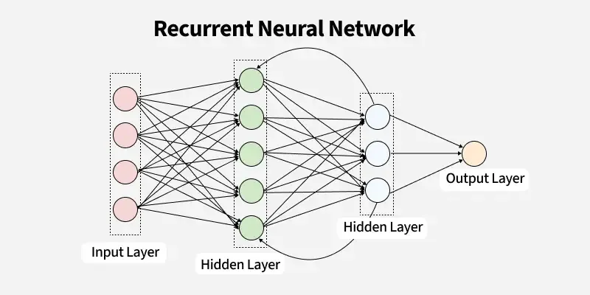
Architecture of RNN
The architecture of an RNN consists of several key components that work together to process sequential data. The following are the major components:
1. Input Layer: receives the sequential data, which could be time series data, text, or other forms of sequential data. Each element in the sequence is fed to the network one step at a time.
2. Hidden Layer(s): It is the core of the RNN. At each time step, the hidden layer updates its state based on the current input and the previous hidden state. This hidden state acts as the "memory" of the network, allowing it to capture dependencies across time steps.
3. Output Layer: This layer generates the final output of the network. For classification tasks, this might be a probability distribution over the possible classes. In regression tasks, the output could be a single continuous value.
Key Features of RNNs
Recurrent Neural Networks (RNNs) have unique characteristics that make them highly effective for processing sequential data.
1. Activation Functions: RNNs typically use activation functions such as tanh and ReLU are used in the hidden layers to introduce non-linearity, enabling the RNN to learn complex patterns.
2. Weight Sharing: RNNs use weight sharing, that the same set of weights is used at each time step, ensuring that the model has the same structure regardless of the time step.
3. Backpropagation Through Time (BPTT): RNNs use a process called Backpropagation Through Time to update the weights during training. BPTT unrolls the RNN across time steps and calculates the gradient of the loss function with respect to each weight by propagating the errors backward through the network.

3. Basic Idea of RNN
An RNN processes one element at a time and maintains a hidden state.
The hidden state acts like memory.
At each time step:
$$h_{t}=f(W_{h}h_{t-1}+W_{x}x_{t}+b)$$
Where:
- $x_{t}$= current input
- $h_{t-1}$= previous hidden state
- $h_{t}$= new hidden state
- $W_{x},W_{h}$= weights
- $b$= bias
- $f$= activation (tanh / ReLU)
Output:
$$y_{t}=W_{y}h_{t}$$

4. How an RNN Works (Step by Step)
Consider sequence:
Input: I → love → deep → learning
Step 1: First Word
Input: I
Hidden state initially:
h0 = 0
Compute:
h1 = f(Wx * x1 + Wh * h0)
Memory now stores information about I

Step 2: Second Word
Input: love
Now:
h2 = f(Wx * x2 + Wh * h1)
Memory now stores:
"I love"

Step 3: Third Word
Input: deep
h3 = f(Wx * x3 + Wh * h2)
Memory now contains:
"I love deep"

Step 4: Fourth Word
Input: learning
h4 = f(Wx * x4 + Wh * h3)
Memory now contains full context.

5. Unrolling the RNN
RNNs are usually visualized by unrolling through time.
Instead of one loop, we represent:
x1 → h1 → y1
x2 → h2 → y2
x3 → h3 → y3
x4 → h4 → y4
Each time step has:
- Same weights
- Different inputs
This is called parameter sharing.
Advantages:
- Fewer parameters
- Learns sequence patterns

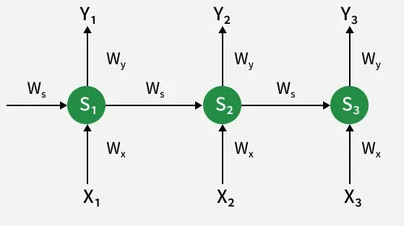
1️⃣ Main Idea of the Diagram
The network processes a sequence of inputs one step at a time.
At each time step, the RNN:
- Takes a new input
- Uses the previous hidden state (memory)
- Produces an output
- Passes the updated hidden state to the next step
This allows the model to remember past information.

Step-by-Step Explanation
2️⃣ Time Steps
The diagram shows three time steps:
- t₁ → t₂ → t₃
Represented by:
Time | Input | State | Output
1 | X₁ | S₁ | Y₁
2 | X₂ | S₂ | Y₂
3 | X₃ | S₃ | Y₃
Example (Sentence processing):
Word | Input
I | X₁
love | X₂
AI | X₃

3️⃣ Components in the Diagram
🟢 Hidden States (S₁, S₂, S₃)
The green circles represent the hidden states.
Hidden state acts as the memory of the network.
S₁ → S₂ → S₃
Each hidden state contains information from:
- Current input
- Previous hidden state
Example:
S₂ remembers information from X₁ and X₂

4️⃣ Inputs (X₁, X₂, X₃)
These are the input vectors at each time step.
Examples of input sequences:
Application | Example Input
NLP | words in a sentence
Speech | audio frames
Time series | stock prices
Video | frames
In the diagram:
X₁ → S₁
X₂ → S₂
X₃ → S₃

5️⃣ Outputs (Y₁, Y₂, Y₃)
Each state produces an output.
S₁ → Y₁
S₂ → Y₂
S₃ → Y₃
Example tasks:
Task | Output
Sentiment analysis | positive/negative
POS tagging | part of speech
Translation | translated word

6️⃣ Weight Matrices
The arrows show weights used in the network.
Wₓ (Input Weight)
Connects input → hidden state
X₁ → S₁
X₂ → S₂
X₃ → S₃
Formula contribution:
$$W_{x}X_{t}$$

Wₛ (Recurrent Weight)
Connects previous hidden state → next hidden state
S₁ → S₂
S₂ → S₃
This is the memory mechanism.
Formula contribution:
$$W_{s}S_{t-1}$$

Wᵧ (Output Weight)
Connects hidden state → output
S₁ → Y₁
S₂ → Y₂
S₃ → Y₃
Formula contribution:
$$W_{y}S_{t}$$

7️⃣ Mathematical Representation
Hidden State Update
At each time step:
$$S_{t}=f(W_{x}X_{t}+W_{s}S_{t-1})$$
Where
- $X_{t}$= input
- $S_{t-1}$= previous hidden state
- $f$= activation function (usually tanh or ReLU)

Output Calculation
$$Y_{t}=g(W_{y}S_{t})$$
Where
- $g$= activation (Softmax, Sigmoid etc.)

8️⃣ Important Property: Shared Weights
Notice that the same weights are used for all time steps:
- Wₓ
- Wₛ
- Wᵧ
This means:
same network repeated over time
Advantages:
- fewer parameters
- better learning of sequences

6. Types of RNN Architectures
1️⃣ One-to-One (Single Input → Single Output)
Application: Image Classification
- Input: Image
- Output: Class label
Example:
- A system detects whether an X-ray shows pneumonia or normal.
Real platforms:
- Google Photos automatically classifying images
- Medical diagnosis systems detecting diseases from scans
Another example:
- Email Spam Detection
  - Input: Email
  - Output: Spam / Not Spam
Used in:
- Gmail spam filtering

2️⃣ One-to-Many (Single Input → Sequence Output)
Application: Image Captioning
- Input: Image
- Output: Sentence describing the image
Example:
Input: Image of a dog
Output: "A dog playing in the park"
Used in:
- Accessibility tools for visually impaired users
- Google Photos caption generation
Another example:
Music Generation
- Input: Initial music style or note
- Output: Generated melody sequence
Used in:
- AI music tools like AIVA

3️⃣ Many-to-One (Sequence Input → Single Output)
Application: Sentiment Analysis
- Input: Sentence or review
- Output: Positive / Negative / Neutral
Example:
Input: "This product is amazing"
Output: Positive
Used in:
- Product review analysis on Amazon
- Social media sentiment tracking
Another example:
Spam SMS Detection
- Input: Full SMS message
- Output: Spam / Not Spam

4️⃣ Many-to-Many (Sequence Input → Sequence Output)
Application: Language Translation
Example using Google Translate
Input: "How are you?"
Output: "¿Cómo estás?"
Another example:
Speech Recognition
- Input: Audio waveform
- Output: Text transcription
Used in:
- Siri
- Google Assistant
- Alexa

7. Training RNN: Backpropagation Through Time (BPTT)
RNNs are trained using Backpropagation Through Time (BPTT).
Process:
- Forward pass through sequence
- Compute loss
- Unroll network
- Backpropagate error through each time step
Example:
Loss = L1 + L2 + L3 + L4
Gradients propagate backward:
t4 → t3 → t2 → t1

8. Major Challenge: Vanishing Gradient Problem
The biggest problem in RNNs is the Vanishing Gradient Problem.
It occurs during backpropagation.

What Happens During Backpropagation
Gradient calculation:
$$\frac{∂L}{∂W}$$
For RNNs:
Gradients multiply many times:
$$\frac{∂L}{∂h_{t}}=\frac{∂L}{∂h_{T}}×\prod_{k=t}^{T}{\frac{∂h_{k}}{∂h_{k-1}}}$$
If the derivatives are less than 1, repeated multiplication makes them very small.
Example:
0.5 × 0.5 × 0.5 × 0.5 × 0.5
Result:
0.03125
After many steps:
≈ 0
Thus gradient vanishes.

9. Why Vanishing Gradient is a Problem
When gradients become very small:
Weights stop updating.
This causes:
- Early layers learn nothing
- Network forgets long-term dependencies
Example sentence:
I grew up in France… I speak fluent ____.
The word France appears far earlier.
The model cannot connect it to French.

10. Exploding Gradient Problem
Opposite issue:
If derivatives > 1
Example:
1.5 × 1.5 × 1.5 × 1.5 × 1.5
Result:
7.59
After many steps:
→ extremely large
This causes:
- unstable training
- large weight updates
- NaN loss

11. Solutions to Vanishing Gradient
Researchers developed improved RNN architectures.
1. Long Short-Term Memory
Long Short-Term Memory (LSTM)
Key idea:
Special gates control memory flow.
Gates:
- Forget gate
- Input gate
- Output gate
Advantages:
- Captures long-term dependencies
- Reduces vanishing gradient

2. Gated Recurrent Unit
Gated Recurrent Unit (GRU)
Simpler version of LSTM.
Uses:
- Update gate
- Reset gate
Advantages:
- Faster
- Fewer parameters

3. Gradient Clipping
To solve exploding gradients:
if gradient > threshold:
gradient = threshold
Used in frameworks like TensorFlow and PyTorch.

12. Activation Functions Used in RNN
Common ones:
Tanh
Range:
-1 to 1
Most common in RNNs.

Sigmoid
Range:
0 to 1
Used in gates of LSTM/GRU.

ReLU
Used sometimes but can cause exploding gradients.

13. Applications of RNN
Natural Language Processing
- Machine translation
- Sentiment analysis
- Text generation

Speech Recognition
Example systems from Google.

Time Series Forecasting
Examples:
- Stock prediction
- Weather forecasting

Video Analysis
Frame sequence modeling.

14. Limitations of RNN
- Slow training (sequential processing)
- Difficult to parallelize
- Vanishing gradients
- Hard to capture long dependencies
These issues led to architectures like:
Transformer (deep learning architecture)
Used in modern models like GPT.

Variants of Recurrent Neural Networks (RNNs)
There are several variations of RNNs, each designed to address specific challenges or optimize for certain tasks:
1. Vanilla RNN
This simplest form of RNN consists of a single hidden layer where weights are shared across time steps. Vanilla RNNs are suitable for learning short-term dependencies but are limited by the vanishing gradient problem, which hampers long-sequence learning.
2. Bidirectional RNNs
Bidirectional RNNs process inputs in both forward and backward directions, capturing both past and future context for each time step. This architecture is ideal for tasks where the entire sequence is available, such as named entity recognition and question answering.
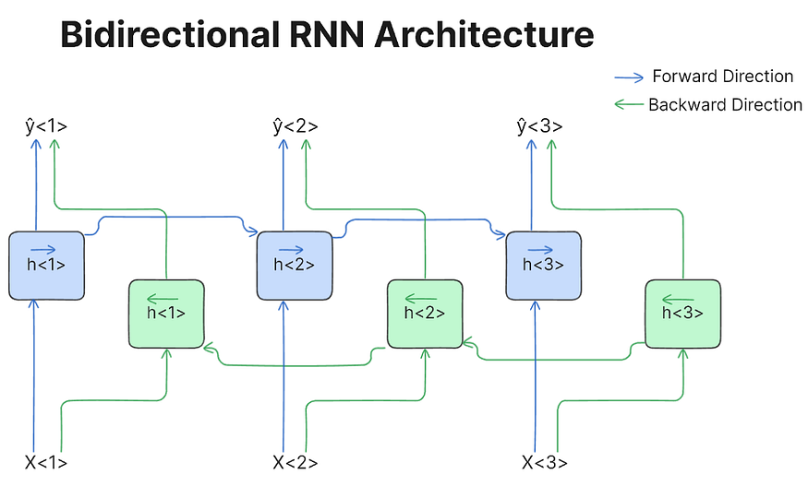
3. Long Short-Term Memory Networks (LSTMs)
Long Short-Term Memory Networks (LSTMs) introduce a memory mechanism to overcome the vanishing gradient problem. Each LSTM cell has three gates:
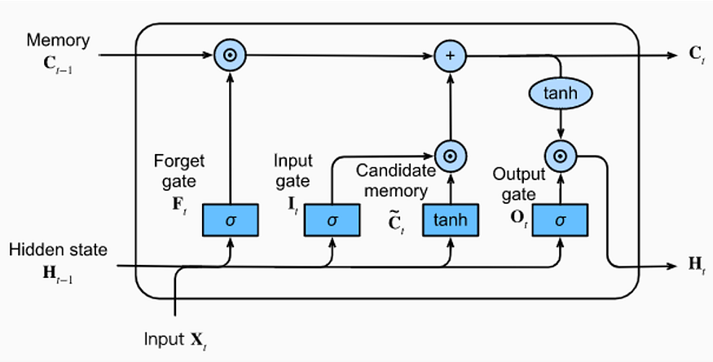
- Input Gate: Controls how much new information should be added to the cell state.
- Forget Gate: Decides what past information should be discarded.
- Output Gate: Regulates what information should be output at the current step. This selective memory enables LSTMs to handle long-term dependencies, making them ideal for tasks where earlier context is critical.

4. Gated Recurrent Units (GRUs)
Gated Recurrent Units (GRUs) simplify LSTMs by combining the input and forget gates into a single update gate and streamlining the output mechanism. This design is computationally efficient, often performing similarly to LSTMs and is useful in tasks where simplicity and faster training are beneficial.
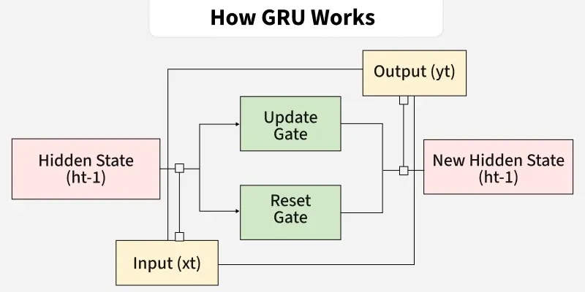

The difference between Backpropagation and Backpropagation Through Time (BPTT) mainly comes from the type of neural network and data they handle in Deep Learning.

1️⃣ Backpropagation
Backpropagation is the algorithm used to train feedforward neural networks.
Examples:
- Artificial Neural Networks (ANN)
- Convolutional Neural Networks
How it works
- Input passes forward through layers.
- Output is produced.
- Error between predicted output and actual output is calculated.
- Error is propagated backward through the layers.
- Weights are updated using gradients.
Structure
Input → Hidden Layer → Output
↑
Backpropagation
Key Idea
Error flows back through layers.

2️⃣ Backpropagation Through Time (BPTT)
BPTT is an extension of backpropagation used to train Recurrent Neural Networks (RNNs).
RNNs process sequential data like:
- text
- speech
- time series
How it works
- RNN processes inputs across time steps.
- Hidden states pass information from previous time steps.
- The network is unrolled through time.
- Error is propagated backward across time steps.
Structure
Time step 1 → Time step 2 → Time step 3
↑ ↑ ↑
Backpropagation through time
Key Idea
Error flows back through time steps.

4️⃣ Key Differences
Feature | Backpropagation | BPTT
Used in | Feedforward Networks | Recurrent Neural Networks
Data type | Independent data | Sequential data
Error propagation | Through layers | Through time steps
Network structure | Static | Unrolled across time
Memory of past | No | Yes (hidden state)

